# C:\Users\Suhong Liang\AppData\Local\Microsoft\Windows\INetCache\Content.MSO\7C9FADCF.tmp

Baton Rouge Website Analytics

Dan Pham - Kostiantyn Reva - Navdeep Singh - Precious Osarenren - Suhong Liang

Big Data Analytics – BDAT1009

Professor Keith Connell

Tuesday, April 9th, 2019

Table of Contents

INTRODUCTION 3

KEY CHAGES AND OVERALL PERFORMANCE 6

Change of domains 6

Site Map and Functional Pages 6

Overall Performance Metrics 7

IN-DEPTH STUDY AND RECOMMENTDATION 9

Sitemap 9

Page Speed Analysis on Brla.gov (Precious) 10

SEO Analysis 10

Tagging problem 11

COMPARISON WITH BLOOMINGTON WEBSITE (Precious) 12

References 13

Appendix: Dashboard visualization 14

# Introduction

Baton Rouge is Louisiana’s “Capital City” and the hub of all things Louisiana (<https://www.visitbatonrouge.com/>) - with those words one of the city website domain introduces the city of Baton Rouge. The city seems to be a key, central location—just 60 minutes away from New Orleans and Lafayette—Baton Rouge is the flawless city to discover the wide-ranging culture of the state of Louisiana. Baton Rouge meaning “Red Stick,” in French boast of over 300 years of history, much of which can be seen in the city’s diverse architecture and learned through their unique culture. Baton Rouge is the 99th most populous city in the United States and the 16th most populous state capital. In 2017 estimate, Baton Rouge had a population of 227,549 with it been the center of Greater Baton Rouge, the second-largest metropolitan area in Louisiana. Baton Rouge is a major motion picture, industrial, research, petrochemical, medical, and growing technology center of the south of United States. It is also the location of Southern University, the flagship institution of the Southern University System, the only historically black college system in the united states.

Baton Rouge is a culturally rich center, with settlement by immigrants from several European nations and African peoples brought to North America as slaves or indentured servants. It was ruled by various governments: British, Spanish the Republic of West Florida, Confederate, United States and others. The city has various websites and domains to communicate important information to the city’s residents and visitors and the websites includes data.ebrgis.opendata.arcgis.com, budget.brla.gov, my.brla.gov, 311.brla.gov, data.brla.gov, gis.brla.gov, and brgov.com. In 2018 the city lunch two new websites: city.brla.gov and www.brla.gov and it’s seems safe for us to assume that the brgov.com split into the two new websites. Each of the city’s websites has a specific purpose as stated below:

data.ebrgis.opendata.arcgis.com - The East Baton Rouge Geographic Information System (EBRGIS) Open Data site provides access to all the city’s published GIS data making it freely available to the public. The site is intended to augment Open Data BR and the EBRGIS Map Portal.

budget.brla.gov - The primary role of the website is to provide budgeting and financial information to the Metropolitan Council to supply council members with information pertaining to issues and related items on the city's council agenda.

my.brla.gov – This website aims to provide information to the residents of Baton Rouge in an easily searchable format to help them quickly understand what’s happening around their home or business at any given time and help them stay up-to-date with email alerts they can easily customize through this platform.

311.brla.gov – This website contains dataset from the city of Baton Rouge which includes all requests for service received from the City-Parish 311 Call Center, including requests for service submitted online and through the Red Stick 311 mobile application, dating back to January 1, 2016 (http://us-city.census.okfn.org/entry/batonrouge/service-requests)

data.brla.gov – This website is Baton Rouge’s Official Open Data Portal. Open Data BR is part of the city’s comprehensive effort to build more effective, responsive, transparent, and digital local government agencies in Baton Rouge, Louisiana.

gis.brla.gov - Geographic Information Systems (GIS) are platforms for storing location-based data which can be used for maps, analysis, operations, and decision-making. The City of Baton Rouge uses GIS technology to keep track of addresses, property, streets, land use, and many other assets

brgov.com - split into the two new websites that is city.brla.gov and www.brla.gov

www.brla.gov – The website provides information that is easily accessible for all residents to request services and find the information they need as quickly as possible, The BRLA.gov addresses these needs through robust features, user-focused design elements, and key functionality that supports two-way communication with our residents.

The purpose of this paper is to analyze the city of Baton Rouge websites traffic and to provide an understanding of the performance of the websites and recommendations for future improvements. To help us with the analysis, this paper will be using some sets of key metrics: pageview, bounce rate, unique view, entrance, exit rate, average time on page. Pageviews (also called screen views for mobile) is the total count of how many times any user lands on an individual page on the website. This includes repeatedly landing on the same page during one session, so if a user refreshes the page, this counts as an additional page view on your site while Unique page views is the number of times a page was accessed at least once during a session that is to say, it doesn’t count multiple views of a page by the same user in the same session instead considering them as a single view. On another note Bounce rate is the total immediate exit on one page divided by total session begin by that page and Exit rate is the total exit on one page divided by the total session on that page. Also, Entrance is the number of entries by visitors into the pages of the website. An example is if the user enters a website through the website's home page, it is accounted as one entry and average time on page is the time in seconds a visitor spent on a specific page.

It’s imperative to state in this introduction the method of aggregation we will be using for the analysis of the website reviews. For the pageview, unique view, and entrance, we will be using sum of individual views while for Bounce rate, exit rate, and average time on page we will be using average views for the websites.

WEB ANALYTICS<N>

The city of Baton Rouge, US changed their website domain from BRGov.com to BRLA.gov and also revamped the whole website. The website had the older address for the past 17 years and the new design provides more robust features, user-featured elements and enhanced functionality for doing business.

# Key Changes and Overall Performance

## Change of domains

The City of Baton Rouge’s primary domain brgov.com witnessed increasing views from the year 2014 to 2016. The total number of combined page views for the year 2016 and 2017 were more than 7 million. Although, the page views decreased from 4.1 million in 2016 to around 3 million in 2017, the year 2018 saw a drastic decrease in the total page views with a number summing to just 576k views.

On the other hand, for the year 2018 we see an addition of a new domain city.brla.gov and a drastic increase on the sum of page views (highest for 2018) with the number totaling to approximately 1.6 million. The most probable cause of this shift can be explained if there is a change of domain from brgov.com to city.brla.gov. With some further digging and research it is found out that the City of Baton Rouge changed the website domain to a new name and fully redesigned the homepage with access buttons and new services. These services included but were not limited to integrating calendar feature and incorporating a “Notify Me” feature to provide real time updates for the visiting and signed up users.

## Site Map and Functional Pages

The City of Baton Rouge had just one functional domain brgov.com in the year 2014 with all the features and functionality. The city later, starting from the year 2015 split the main website into various domains, one for each department. There were 5 sub domains for the city’s main website in 2015 which increased to 8 in the year 2018. We observe that the main homepage domain brla.gov has the highest sum of overall page views regardless.

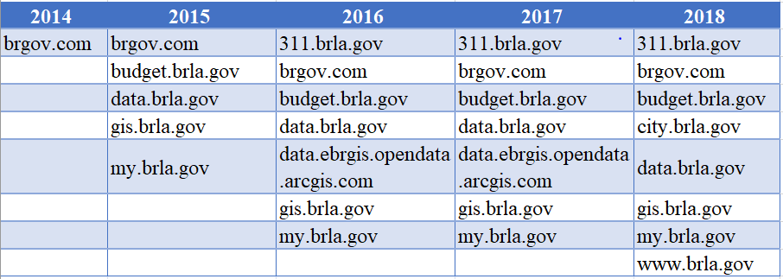We can see a table below which lists all the sub domains for City of Baton Rouge primary website.

## Overall Performance Metrics

The data analyzed gives some interesting insights about the site performance and helps to delineate an overall performance trend. The following points sum up the overall performance:

The combined page views increase progressively every year with exception to 2017 and drastic drop in 2018, which can be explained by the shift of the website to a new domain in the year 2018. This is supported by the data given and external sources. For the purposes of our analysis and data visualization we treat brgov.com and city.brla.gov as the same domain, since the main website just changed domains.

The most observable and change comes in the figures for sum of entrances. We can see that the sum of entrances increases on yearly basis with most drastic change occurring in 2017. In the year 2017 the sum of entrances rises to 6.6 million from 2.5 million in 2016 (~275% increase) whereas the sum of total page views as well as the unique page views, both are less than the entrances final number. The same trend is observed for the year 2018. Since this trend doesn’t make much sense arithmetically, this mismatch points out a problem. We can see two reasons for this trend, either there is mismatch with the traffic tags or there is a change in the definition of metrics by the data collection agency. However, the former reason seems very unlikely due to the universally accepted definition of “Entrance”. The likeliness of a traffic mismatch or an attack is high.

We observe that the average time spent by the user on the website has been increasing overall with a sharp rise in 2016 (65 secs) from 51 secs in 2015. The average time spent is approximately 64 seconds in 2018, which is indictive of the improving content quantity and quality on the website. As a result, the user spends more time and is more likely to find what he/she is looking for.

A new metric page view per unique view is calculated which can be assumed to be approximately equal to page view per user. It can be observed that the page views per user rises from 2014 to 2018 with 2018 being the year where a user is attributed to 2-page views.

The sum of unique views decreases from 2014 to 2018 except the year 2016 with 3.19 million unique page views. The unique page views for 2017 and 2018 combined are 4.2 million. This shows that there is a decrease in the user base. An investigative study of the traffic coming to the website can be helpful to solve this issue as it might point out to the region or the kind of user base responsible for this drop.

An increasing trend is observed in the average bounce rate and the average exit rate, collective for all the domains, with a decrease for the years 2015 - 2017. We would need to breakdown the traffic for the team to analyze and track the points responsible for this increase. especially for the year 2018. By breaking down the exit rate and bounce rate for each domain we can observe the similar trend (increasing) with an exception to “budget.brla.gov”. So, our analysis for overall exit and bounce rate holds true for overall performance measure.

# In-depth Study and Recommendation

## Sitemap

The data for The City of Baton Rouge enables us to run an in-depth analysis on the sitemap, which is the analysis of the sub-page levels (or URLs) within the main website. With our analysis we have found that there are 31 level 1 sub-pages for my.brla.gov which include an interactive map of open neighborhood with information about various parks, schools, libraries etc. in the city. And the main website brla.gov has 1190 level sub-pages. Based upon the data extracted we can recommend the following solutions to increase the overall performance of the website.

The City of Baton Rouge should consider reconstructing the site map for the following sites which have hundreds of level 1 sub-pages. Brgov.com has more than 1300 level 1 sub-pages, Brla.gov as stated above has close to 1200, and data.brla.gov has approximately 94 level 1 sub-pages which not only makes the navigation for a user difficult and frustrating, the deeper the user is inside the website the easier it is for him/her to loose context of where they are and might result in overall bad experience. Especially in the case of data.brla.gov, not only the sub-pages are exceedingly high in number, the names of this sub-pages are vague for e.g. w, d, roe, ap etc. which result in bad SEO score and unpleasant user experience with navigation.

The website should be further grouped into maximum of 10-15 sublevel pages so that it is not only simpler for the first-time user to locate what he/she is looking for but also the path is renamed in a more user-friendly fashion to improve the SEO score. SEOptimer.com is used to analyze a URL and the results are summarized below.

Due to such a high number of sub-pages and lack of grouping, paths have very long URLs generated, some of them with 39 levels (check below for example). These lengthy paths might cause of a lot of problem and possible errors while generating APIs/URLs for external use. Also, these lengthy URLs affect the Search Engine Optimization factor because of their inability to be easily readable and friendly to humans or search engines. Hence, the search engine results are poor are do not direct the user for what he/she is looking for.

|  |
| --- |
| <http://brgov.com/dept/brpd/www.brgov.com/dept/dept/dept/dept/dept/dept/dept/dept/dept/dept/dept/dept/dept/dept/dept/dept/dept/dept/dept/planning/dept/dept/dept/planning/dept/planning/dept/dept/dept/dept/planning/dept/dept/dept/dept/hr/> |

## Page Speed Analysis on Brla.gov (Precious)

## SEO Analysis

Search Engine Optimization (SEO) refers to the ranking of a website or page when a related search query is entered in the search engine. SEO is an important metric which helps to strengthen the online presence of a website and beneficial for the user to land to the appropriate page/website in less time. The main website with URL brla.gov is analyzed using SEOptimer.com tool and the following insights and recommendations are summarized from the results.

The webpage is missing the meta description tag. A meta description tag refers to the HTML attributes which provide a concise summary of the website/webpage and its contents. It is generally a part of the front-end code and helps the search engine to understand the type of webpage and its corresponding insides. A good meta description tag helps to increase the online ranking of the website in a search engine.

It is also observed that the webpage is not making effective use of the HTML header tags and therefore, makes it difficult for the search engine to keep a track of the various sections of the page and as a result it cannot attribute specific or appropriate keywords to the page to improve its ranking. The results from the tool show that the frequency of <H1> and <H2> header tags for the webpage is 0.

As a result, the important keywords telling of the important sections of the webpage and its corresponding contents are not distributed well across the website. The frequency of <H4> tags is maximum with the number totaling to 140. These important keywords like are nowhere to be found in title or Meta Description Tags. For a webpage to have good search engine ranking it is required for the content to be focused around these important keywords and also their presence inside the various HTML tags is of importance.

The images on the webpage are missing the ALT attribute. The ALT attribute is used to display an alternate text in case an image fails to load so that the user has an idea what the blank space was supposed to show. It helps the user to keep engaged, improve the SEO performance, and makes the webpage seem more reliable.

It has also been observed that the webpage includes poorly optimized images. These images are neither compressed to be optimized nor formatted appropriately, which results in reduce in page load performance and hence affects the page ranking.

## Tagging problem

In 2016, the sum of entrance of the brgov.com website was 1,067,830 while the sum of page views was 4,147,586 and this is normal having the sum of page views greater than the sum of entrance. However, in 2017 the sum entrance was 4,001,317 which amounted to 275% increase over 2016 sum of entrance and the paradox became clearer when the sum of entrance for 2017 is compared with the sum of page views for 2017. The sum of page views for 2017 was 3,063,614 which meant that the sum of entrance was greater than the sum of page views which is very unlikely and because of this inconsistency, we assume that as a result of the transition from brgov.com website to brla.gov, pageviews in brgov.com weren’t recognized. Even so, when we add up pageview of all website of the city in 2017, the number still did not amount to the sum of entrance of one single website (brgov.com) and this led to the conclusion that there are some problems in the brgov.com website with tagging systems. It is worth noting that this is an ongoing issue in 2018 and this article is recommending a roll back to the website change logs between 2016 -2017, track if any change in tagging and therefore update it as necessary.

# Comparison with Bloomington Website (Precious)

# References

https://en.wikipedia.org/wiki/Baton_Rouge,_Louisiana

https://developers.google.com/speed/pagespeed/insights/?url=https%3A%2F%2Fwww.brla.gov%2F

https://www.similarweb.com/website/brla.gov

https://www.seoptimer.com/brla.gov

https://www.visitbatonrouge.com

https://www.city.brla.gov

https://www.brla.gov

https://www.gis.brla.gov

https://www.data.brla.gov

https://www.311.brla.gov

https://www.my.brla.gov

https://www.budget.brla.gov

https://www.data.ebrgis.opendata.arcgis.com

https://en.wikipedia.org/wiki/Baton_Rouge,_Louisiana

<https://en.wikipedia.org/wiki/Bloomington,_Minnesota>

<https://en.wikipedia.org/wiki/Search_engine_optimization>

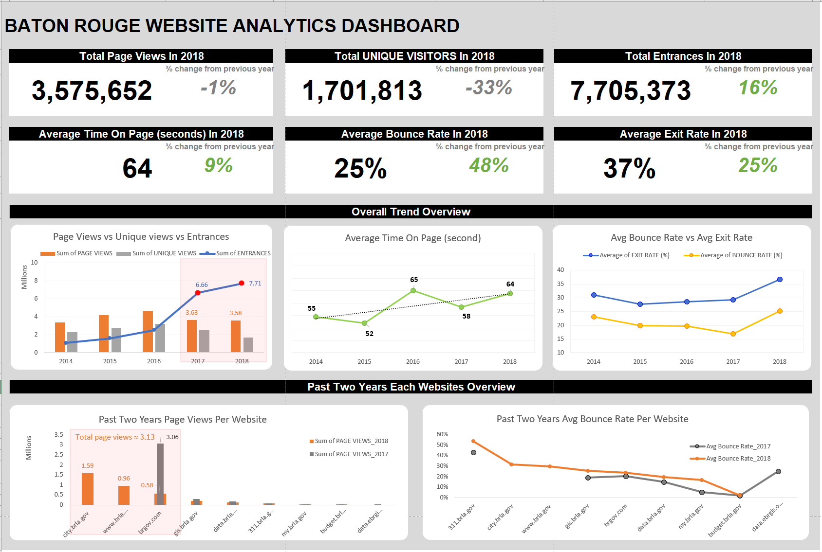Appendix: Dashboard visualization